Abstract

The home automation becomes important, because it gives the user the comfortable and easy way for using their home appliances. The implementation and design of home automation control used two methods, Microcontroller development board and communication between PC and board is done by UART to control of the selective home devices with integral security and protected system. The devices has been distributed and has its own board, this board is connected to the personal computer (PC) through one serial port RS-232 via microcontroller. The software consist of the C language for programming microcontroller (LPC-214X series) and visual basic language that uses to communicate between PC and the board is UART. The whole system is made by using a single lpc-2148 board which consists of temperature sensor which is one of their many peripherals. The other peripherals like LCD display, LEDs and interrupts were used.

Introduction

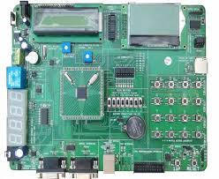

This project was made on the development kit created by CRANES company which consists of LPC 2148 microcontroller chip. It is made of ARM architecture. The ARM architecture is the most widely used 32-bit instruction set architecture.ARM offers several microprocessor core designs, including the ARM7, ARM9, ARM11, Cortex-A8, Cortex-A9 and Cortex-A15. VLSI Technology, Inc was chosen as silicon partner, since it already supplied Acorn with ROMs and some custom chips. VLSI produced the firs ARM silicon and it worked the first time and came to be termed as ARM1.

Description

“Home Automation” implements the emerging applications of the latest

technology. Using GSM networks, a control system has been proposed that will act as an

embedded system which can monitor and control appliances and other devices locally

using built-in input and output peripherals. Here in our project we are using a development board which consists of the LPC 2148 Microcontroller chipset. It also has many other components like temperature sensor, LCD Display, LED’s, Vectored Interrupt controller(VIC), UART and many other useful peripherals. Instead of using the GSM networks for the transmission and receiving of the messages we are going to use UART in this project.

Remotely the system allows the user to effectively monitor and control the house/office

appliances and equipments via the mobile phone set by sending commands in the form of

SMS messages and receiving the appliances status. The main concept behind the project

is receiving the sent message through UART and processing it further as required to perform several

operations. The type of the operation to be performed depends on the nature of the the message

sent. The principle in which the project is based is fairly simple. First, the sent message in UART is

stored and it sends signals to the microcontroller to execute the followed operations as per the message and the intermediate hardware or the development kit that we have used will measure the readings through the kit components like temperature sensor and gives the output through the UART.

By programming the microcontroller we used the temperature sensor to monitor the temperature of air conditioners of houses or offices of the people and using UART to send and receive messages to show the temperature of the rooms. The person who has put up the home automation needs to send the message to know the temperature of their respective rooms so as to monitor the temperature they need. As the person sends the message to know their room temperature, the temperature sensor senses the temperature and gives back the message of room temperature. Now if the person decides to lower the temperature he needs to send another message and the microcontroller controls the temperature as needed by the person.

Let us take another case that the person has send the message to lower the temperature of the room. So when the room temperature gets reduced as required by the person then the ac should automatically be turned off. This is where the microcontroller comes to work and switches off the air conditioner

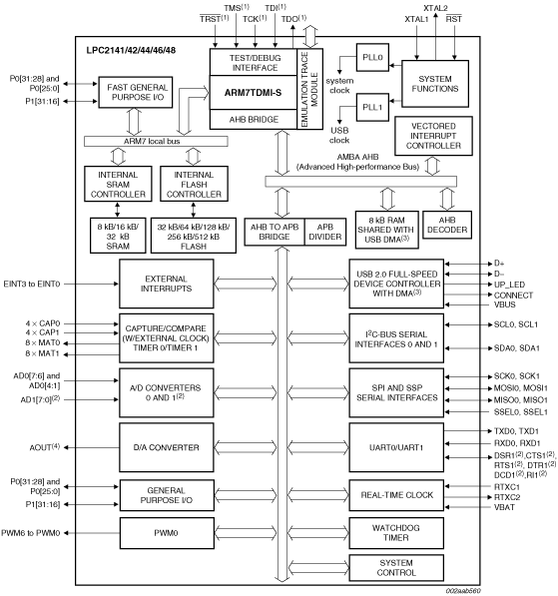

Algorithm

1. Start
2. Initialization of ADC, LCD, Uart(GSM),LED(Device), sensors by sending commands and getting response
3. Defining messages, commands and variables
4. Display the title of project on LCD
5. Read he message from UART (GSM)
6. Compare the received message with pre-defined words
7. If the received message matches with the pre-defined word do the respective functions associated with the message AND give response back to the UART (GSM) if needed
8. If received message does not matches the pre-defined word then send a message to user through UART i.e. “Invalid Command”
9. If the message is “TEMP” or “temp” give back the result of present temperature in C to user
10. If message is “ON” or “on” turn on the LED(AC) and the send the message back to the UART (GSM) as “Device is on”.
11. If message is “OFF” or “off” turn off the LED(AC) and the send the message back to the UART (GSM) as “Device is off”.
12. If the message is “SET” or “set” then take the threshold temperature for AC Operation from the user then give a message back to the user through UART (GSM) that is “SET TO:_”
13. Continue again from the step 5 and do the required steps according to the received message to make a successful home automation work
14. Stop

Programs

Attached to the files and these contain main.c, function.c, accident_zone_detection.c and two created header files proto.h and sentence.h